Tender for EPC tender analyses
Template

EFFECT4buildings Toolbox:
Energy Performance Contracting; Annex 4

The project “Effective Financing Tools for implementing Energy Efficiency in Buildings” (EFFECT4buildings) develops in collaboration with public building managers a comprehensive decision-making support toolbox with a set of financial instruments: Financial calculation tools; Bundling; Funding; Convincing decision makers; Energy Performance Contracting; Multi Service Contracting; Green Lease Contracting; Prosumerism. The tools and instruments chosen by the project has the biggest potential to help building managers to overcome financial barriers, based on nearly 40 interviews with the target group. The project improves these tools through different real cases.
To make sure building managers invest in the best available solutions, more knowledge on different possibilities is needed as well as confirmation from colleagues that the solutions performs well. EFFECT4buildings mapped technological solutions for energy efficiency in buildings with the aim to share knowledge and experiences of energy efficiency solutions among building managers in the Baltic Sea Region.

Energy Performance Contracting (EPC) is a well-tested and successful model for energy saving. It is used by public building owners to reach climate and energy targets at a faster pace than with traditional implementation. There is still a large energy-saving potential in public sector.

This template for tender analyses is based on the Guide to EPC developed in the framework of the EFFECT4buildigs project. The guide introduces a new implementation model based on experiences in the countries involved in the EFFECT4buildings project - its main novelty aspects being contract based partnership during the analyses phase and new award criteria to better fit the goals of building owners.
The Template for tender analyses is part of a toolbox of 9 documents and templates adapted to the new implementation models various phases primarily emphasising the first two phases. Experiences from past EPC projects shows that decisions made early are crucial. The goal is to promote EPC as an energy saving model and simplify the start-up of an EPC project.
The bidders deliver an energy efficiency analysis of 1-3 representative sample buildings as part of the proposal work, using the same template for energy analyses, where measures, investments and savings are summed up.
Below is a schematic overview of the adapted tools and instruments for EPC:

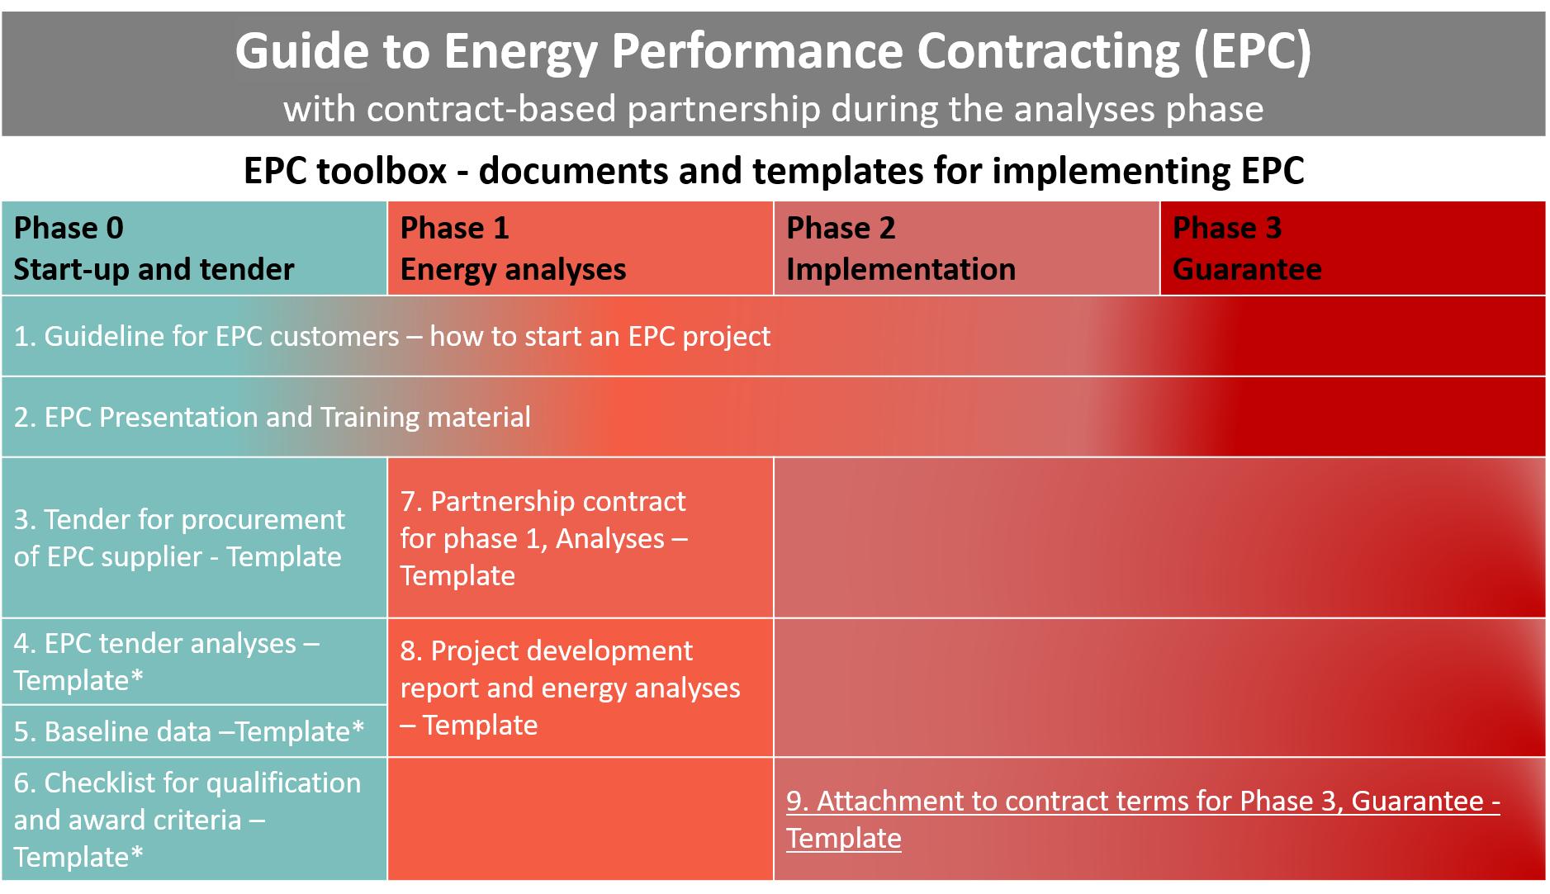
*Not considerably altered compared to standard EPC model documents

How to use the template
- This template is part of EPC offer/bid and should be filled in by the EPC supplier/ESCO/bidder and submitted as an attachment to offer.
- In the table below the tenderer/bidder should state where the client will find the documentation in the EPC offer.
- In the margins you might find important information to users with background information and advice on what sections should be thoroughly checked and adapted to national laws, regulations, and specific project conditions.
- Please make sure all introductory text, texts in the margins and logos and layout are deleted before launching it as an attachment to the EPC tender.
The EFFECT4buildings project is implemented with the support from the EU funding Programme Interreg Baltic Sea Region (European Regional Development Fund) and Norwegian national funding. The aim of the project is to improve the capacity of public building managers in the Baltic Sea Region by providing them with a comprehensive decision-making support toolbox with a set of financial instruments to unlock the investments and lower the risks of implementing energy efficiency measures in buildings owned by public stakeholders. More information: http://www.effect4buildings.se/
Partners

Template for EPC tender analyses

Description of measures for tender analyses

Building 1: [name of building]
Building 2: [name of building]
Building 3: [name of building]

Content

1 Introduction 6
2 Example and description of measure 6
3 example building 1 [name of building] 8
4 Measures example building 1 [Building name and number] 10
5 example building 2 [name of building] 14
6 Measures example building 2 [Building name and number] 17
7 Summary of measures all example buildings – sums transferred to Attachment X 22

Introduction
A tender analysis should be prepared for each of the example buildings/representative buildings. All proposed measures should be included in the template with stated investment and energy savings. EPC suppliers are often asked to supplement with more measures than the template is designed for. If so, please add rows in the tables below. It is the supplier's responsibility to ensure that the measure numbering is unique.
The calculated energy savings in EUR are transferred to the building's collection sheet, where all the savings for the measures are summed.
Fixed energy price to uses by all bidders: Fill in
For all buildings, an energy budget must be developed, before and after proposed measures.

Total present value for each building is added to the collection sheet for each building and is summed in the last chapter. Form for calculation of net present value can be found in toolbox for Financial Calculations.

Example and description of measure
Below is an example of description of energy efficiency (EE) measurements:

Measure [Enter number]
[Name of EE measure] | Overall description of the measure, e.g.  «Lighting Fixtures - LED Replacement»
Description of baseline | Brief and precise description of the current technical state of the buildings. For example: "In building part A from 1970 there are old T8 lighting fixtures in corridors and stalls. There are only on / off switches in the classrooms."
Description of measures | Precise description of the measure. For example: "In building part A from 1970, lighting fixtures will be replaced in corridors and stalls for luminaires with electronic ballasts. Daylight regulation is established in the classrooms."  Measures must be sufficiently described for the assessment of the award criterion quality. Eg. situation plan, if applicable.
Savings stated in unit | Guaranteed savings in kWh, MWh, m³, CO2-evk and similar.
Savings | Guaranteed savings in EUR per year.  When calculating savings, unit prices are used, excl. VAT stated in Appendix X Offer form.  If the measure results in savings of several types of energy, the total saving must be transferred to the building's collection site.  All prices and savings are stated in EUR. ex. VAT.
Investment | The tenderer's offer for the cost of implementation of the measure. All prices are quoted in EUR. ex. VAT.
Preconditions / calculations | Description of the assumptions and calculations of the energy efficiency measure. Here we want a description of all preconditions and calculations, concerning all conditions, which can have an impact on the users' experience. This applies, for example, to changing operating times, brightness (lux), airflow, etc.  It shall be stated how the bidder has calculated the savings. Eg. "X number of luminaires, type XX, will be replaced with new luminaires of type ZZ. Savings per luminaire, with operating hours from 7 am - 4 pm are calculated to…"
Possible future service costs: | In EUR ex. VAT.  An additional EPC Maintenance Contract can be entered into.
Description of related / additional work and how these works are handled. | A description of the related additional work is required, which affects other building parts or installations. Including the extent to which this is done by the supplier.  For example: "When replacing lighting fixtures, removable ceiling panels are replaced due to other sizes of new fixtures. The replacement is included in the offer".

Example building 1 [name of building]

Energy budget example building 1 [name of building]

ENERGY BUDGET BEFORE AND AFTER ALL MEASURES
 | Before measures |  | After measures
 | kWh/year | kWh/m2 year | kWh/ year | kWh/m2 year
Heating
Ventilation
Hot water
Fans / pumps
Lighting
Cooling
Other
SUM

Summary of measures for example building 1 [name of building]

 | 1. Energy savings [EUR/ year] | 2. Investment  [EUR] | Pay-back time (2./1.) [year]
Description of measures - measure 1
[name of measure]
Description of measures - measure 2
[name of measure]
Description of measures - measure 3
[name of measure]
Description of measures - measure 4
[name of measure]
Description of measures - measure 5
[name of measure]
Description of measures - measure 6
[name of measure]
Description of measures - measure 7
[name of measure]
Description of measures - measure 8
[name of measure]
Description of measures - measure 9
[name of measure]
Description of measures - measure 10
[name of measure]
Description of measures - measure 11
[name of measure]
Description of measures - measure 12
[name of measure]
Description of measures - measure 13
[name of measure]
Sum investment
Sum energy saving

Sum net present value profitable measures [EUR]
(from Attachment X Net present value calculation)
Sum net present value all measures [EUR]
(from Attachment X Net present value calculation)

Measures example building 1 [Building name and number]

Measure 1 [name of measure], [name of building]
Measure [Enter number]
Measure
Description of the current state
Description of measure
Savings stated in unit
Savings in EUR / year
Investment in EUR
Preconditions / calculations
Expected product / building part lifetime and any future service costs:
Description of related additional work and how these works will be handled.

Measure 2 [name of measure], [name of building]
Measure [Enter number]
Measure
Description of the current state
Description of measure
Savings stated in unit
Savings in EUR / year
Investment in EUR
Preconditions / calculations
Expected product / building part lifetime and any future service costs:
Description of related additional work and how these works will be handled.

Measure 3 [name of measure], [name of building]
Measure [Enter number]
Measure
Description of the current state
Description of measure
Savings stated in unit
Savings in EUR / year
Investment in EUR
Preconditions / calculations
Expected product / building part lifetime and any future service costs:
Description of related additional work and how these works will be handled.

Measure 4 [name of measure], [name of building]
Measure [Enter number]
Measure
Description of the current state
Description of measure
Savings stated in unit
Savings in EUR / year
Investment in EUR
Preconditions / calculations
Expected product / building part lifetime and any future service costs:
Description of related additional work and how these works will be handled.

Measure 5 [name of measure], [name of building]
Measure [Enter number]
Measure
Description of the current state
Description of measure
Savings stated in unit
Savings in EUR / year
Investment in EUR
Preconditions / calculations
Expected product / building part lifetime and any future service costs:
Description of related additional work and how these works will be handled.

Measure 6 [name of measure], [name of building]
Measure [Enter number]
Measure
Description of the current state
Description of measure
Savings stated in unit
Savings in EUR / year
Investment in EUR
Preconditions / calculations
Expected product / building part lifetime and any future service costs:
Description of related additional work and how these works will be handled.

Measure 7 [name of measure], [name of building]
Measure [Enter number]
Measure
Description of the current state
Description of measure
Savings stated in unit
Savings in EUR / year
Investment in EUR
Preconditions / calculations
Expected product / building part lifetime and any future service costs:
Description of related additional work and how these works will be handled.

Measure 8 [name of measure], [name of building]
Measure [Enter number]
Measure
Description of the current state
Description of measure
Savings stated in unit
Savings in EUR / year
Investment in EUR
Preconditions / calculations
Expected product / building part lifetime and any future service costs:
Description of related additional work and how these works will be handled.

Measure 9 [name of measure], [name of building]
Measure [Enter number]
Measure
Description of the current state
Description of measure
Savings stated in unit
Savings in EUR / year
Investment in EUR
Preconditions / calculations
Expected product / building part lifetime and any future service costs:
Description of related additional work and how these works will be handled.

Measure 10 [name of measure], [name of building]
Measure [Enter number]
Measure
Description of the current state
Description of measure
Savings stated in unit
Savings in EUR / year
Investment in EUR
Preconditions / calculations
Expected product / building part lifetime and any future service costs:
Description of related additional work and how these works will be handled.

Measure 11 [name of measure], [name of building]
Measure [Enter number]
Measure
Description of the current state
Description of measure
Savings stated in unit
Savings in EUR / year
Investment in EUR
Preconditions / calculations
Expected product / building part lifetime and any future service costs:
Description of related additional work and how these works will be handled.

Measure 12 [name of measure], [name of building]
Measure [Enter number]
Measure
Description of the current state
Description of measure
Savings stated in unit
Savings in EUR / year
Investment in EUR
Preconditions / calculations
Expected product / building part lifetime and any future service costs:
Description of related additional work and how these works will be handled.

Measure 13 [name of measure], [name of building]
Measure [Enter number]
Measure
Description of the current state
Description of measure
Savings stated in unit
Savings in EUR / year
Investment in EUR
Preconditions / calculations
Expected product / building part lifetime and any future service costs:
Description of related additional work and how these works will be handled.

Example building 2 [name of building]

Energy budget example building 2 [name of building]
ENERGY BUDGET BEFORE AND AFTER ALL MEASURES
 | Before measrues |  | After measures
 | kWh/year | kWh/m2 year | kWh/ year | kWh/m2 year
Heating
Ventilation
Hot water
Fans / pumps
Lighting
Cooling
Other
SUM

Summary of measures for example building 2 [name of building]
 | 1. Energy savings [EUR/ year] | 2. Investment  [EUR] | Pay-back time (2./1.) [year]
Description of measures - measure 1
[name of measure]
Description of measures - measure 2
[name of measure]
Description of measures - measure 3
[name of measure]
Description of measures - measure 4
[name of measure]
Description of measures - measure 5
[name of measure]
Description of measures - measure 6
[name of measure]
Description of measures - measure 7
[name of measure]
Description of measures - measure 8
[name of measure]
Description of measures - measure 9
[name of measure]
Description of measures - measure 10
[name of measure]
Description of measures - measure 11
[name of measure]
Description of measures - measure 12
[name of measure]
Description of measures - measure 13
[name of measure]
Sum investment
Sum energy saving

Sum net present value profitable measures [EUR]
(from Attachment X Net present value calculation)
Sum net present value all measures [EUR]
(from Attachment X Net present value calculation)

Measures example building 2 [Building name and number]

Measure 1 [name of measure], [name of building]
Measure [Enter number]
Measure
Description of the current state
Description of measure
Savings stated in unit
Savings in EUR / year
Investment in EUR
Preconditions / calculations
Expected product / building part lifetime and any future service costs:
Description of related additional work and how these works will be handled.

Measure 1 [name of measure], [name of building]
Measure [Enter number]
Measure
Description of the current state
Description of measure
Savings stated in unit
Savings in EUR / year
Investment in EUR
Preconditions / calculations
Expected product / building part lifetime and any future service costs:
Description of related additional work and how these works will be handled.

Measure 1 [name of measure], [name of building]
Measure [Enter number]
Measure
Description of the current state
Description of measure
Savings stated in unit
Savings in EUR / year
Investment in EUR
Preconditions / calculations
Expected product / building part lifetime and any future service costs:
Description of related additional work and how these works will be handled.

Measure 1 [name of measure], [name of building]
Measure [Enter number]
Measure
Description of the current state
Description of measure
Savings stated in unit
Savings in EUR / year
Investment in EUR
Preconditions / calculations
Expected product / building part lifetime and any future service costs:
Description of related additional work and how these works will be handled.

Measure 1 [name of measure], [name of building]
Measure [Enter number]
Measure
Description of the current state
Description of measure
Savings stated in unit
Savings in EUR / year
Investment in EUR
Preconditions / calculations
Expected product / building part lifetime and any future service costs:
Description of related additional work and how these works will be handled.

Measure 1 [name of measure], [name of building]
Measure [Enter number]
Measure
Description of the current state
Description of measure
Savings stated in unit
Savings in EUR / year
Investment in EUR
Preconditions / calculations
Expected product / building part lifetime and any future service costs:
Description of related additional work and how these works will be handled.

Measure 1 [name of measure], [name of building]
Measure [Enter number]
Measure
Description of the current state
Description of measure
Savings stated in unit
Savings in EUR / year
Investment in EUR
Preconditions / calculations
Expected product / building part lifetime and any future service costs:
Description of related additional work and how these works will be handled.

Measure 1 [name of measure], [name of building]
Measure [Enter number]
Measure
Description of the current state
Description of measure
Savings stated in unit
Savings in EUR / year
Investment in EUR
Preconditions / calculations
Expected product / building part lifetime and any future service costs:
Description of related additional work and how these works will be handled.

Measure 1 [name of measure], [name of building]
Measure [Enter number]
Measure
Description of the current state
Description of measure
Savings stated in unit
Savings in EUR / year
Investment in EUR
Preconditions / calculations
Expected product / building part lifetime and any future service costs:
Description of related additional work and how these works will be handled.

Measure 1 [name of measure], [name of building]
Measure [Enter number]
Measure
Description of the current state
Description of measure
Savings stated in unit
Savings in EUR / year
Investment in EUR
Preconditions / calculations
Expected product / building part lifetime and any future service costs:
Description of related additional work and how these works will be handled.

Measure 1 [name of measure], [name of building]
Measure [Enter number]
Measure
Description of the current state
Description of measure
Savings stated in unit
Savings in EUR / year
Investment in EUR
Preconditions / calculations
Expected product / building part lifetime and any future service costs:
Description of related additional work and how these works will be handled.

Measure 1 [name of measure], [name of building]
Measure [Enter number]
Measure
Description of the current state
Description of measure
Savings stated in unit
Savings in EUR / year
Investment in EUR
Preconditions / calculations
Expected product / building part lifetime and any future service costs:
Description of related additional work and how these works will be handled.

Measure 1 [name of measure], [name of building]
Measure [Enter number]
Measure
Description of the current state
Description of measure
Savings stated in unit
Savings in EUR / year
Investment in EUR
Preconditions / calculations
Expected product / building part lifetime and any future service costs:
Description of related additional work and how these works will be handled.

Summary of measures all example buildings – sums transferred to Attachment X
1 | Sum investment profitable measures [EUR]
2 | Sum savings profitable measures [Eur/year]
3 | Payback time profitable measures [year]
4 | Sum net present value profitable measures [EUR]  (from Attachment X Net present value calculation)

Form for calculation of net present value can be found in EFFECT4buildings toolbox for Financial Calculations - http://www.effect4buildings.se/
See Template for EPC Mainentance Contract

